Contents

Introduction 2

Technical Details 2

Screen View – 1 2

Wireframe 2

Business Logic / Functionality 2

Screen Change – 2 4

Wireframe 4

Business Logic / Functionality 4

# Introduction

This enhancement will enable admin to assign tasks to installer, sales and IT people. This enhancement will help over all organization to track their work, submit it and at the end of the month evaluate the work done.

# Pre-requisite

Before starting development, developer should provide a proof of concept. It means that developer should show following:

1. A better UI design
2. Approach to complete this task
3. Hours required
4. Due Date

# Technical Details

Though this is a very broad functionality but now we need a small implementation, below are the details:

1. Admin should able to create and assign tasks.
2. Installer, Sales and IT should able to get notification via email and system alert regarding allocated tasks.
3. Installer, Sales and IT should be able to submit their tasks
4. Admin should able to review, reopen and close the task.

Currently, we do not require a new page for it. It should be a plugin (user control) which should be displayed on the website header.

There will be two views of the said functionality.

## Screen View – 1

### Wireframe

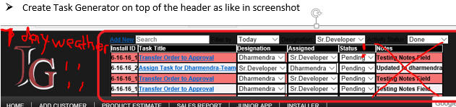

1. There should be atleast 5 tasks displayed in descending order.
2. The task manager should get expand or open in a new window, there should be at least 50 records shown on the expanded view.

### Business Logic / Functionality

#### Section 01

Notice the grid in the red box. On each screen there should be a similar grid with following columns:

1. ID#- autogenerate
2. Task Title: It should be a hyperlink. On clicking it, Edit Task Window should open.
3. Designation: It should be a dropdown, by default it should show the saved task value. It will show all the system designation, on changing designation the assigned dropdown should also get filtered with the user records having the selected designation.
4. Assigned: It should be a checkbox - dropdown, by default it should show the saved value, and it should list all the Sales and Install User of the system. Can be assigned to multiple users.
5. Status: It should be a dropdown with following options:
   1. Assigned
   2. In Progress
   3. Pending
   4. Re-Opened
   5. Closed

#### Section 02

Above grid, there should be following options:

1. A link to Add Task which should open a new window for adding tasks.
2. Task Title: A text box which can help finding similar records
3. Designation: A dropdown which has all the designation records.
4. Assigned: A dropdown which has all the user records filtered by designation.
5. Status: A dropdown which has all the tasks status
6. Created On: Date Picker which will filter records by task created date.

These filters will work in “AND”, it means if user selects a designation “Sr. Developer” and Created On “06/20/2016” then the system will show those records which are created on “06/20/2016” and assigned to “Sr. Developer” designation.

#### Section 03 – Screen Flow

##### Admin Logs In

1. Admin can view all the tasks of the system.
2. Admin cannot delete any task but can add notes and choose close status.
3. Admin cannot edit the closed status task but can add further notes in it.

##### User Logs In

1. User can only view his task
2. User can choose any status but close and reopen

## Screen Change – 2

### Wireframe

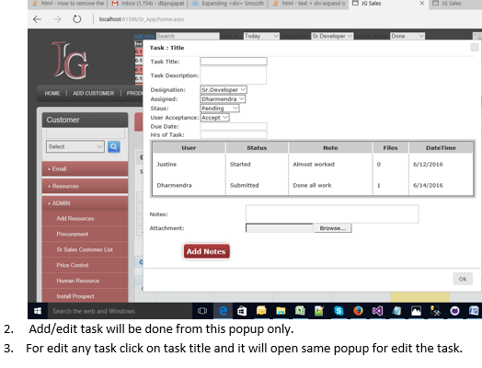

### Business Logic / Functionality

#### Section 01 – Screen Details

This form will have following data entry fields:

1. Task Title: It should be a text box, it can record data upto 250 characters
2. Task Description: It should be a multi-line textbox. It can record data upto 4000 charcters.
3. Designation: It should be a dropdown. It will show all the system designation, on changing designation the assigned dropdown should also get filtered with the user records having the selected designation.
4. Assigned: It should be a dropdown, and it should list all the Sales and Install User of the system.
5. Status: It should be a dropdown with following options:
   1. Assigned
   2. In Progress
   3. Pending
   4. Re-Opened
   5. Closed
6. User Acceptance: It should be a dropdown with following values:
   1. Accepted
   2. Rejected
7. Due Date: It should be a read-only textbox, it should open a Date Picker window.
8. Hrs. of task: It should be a textbox with maximum length of 4 characters.
9. Grid: This would be a history grid, any change to the task should be recorded in this grid. This grid will have 4 columns:
   1. User: The user who has updated the task.
   2. Status: The status of the updated task
   3. Notes: Either user entered Notes or updated entries of the task
   4. Files: Attached files by the user
   5. Updated On: task updated date time
10. Notes: It should be multi-line textbox where user can add notes before updating the tasks.
11. Attachment: User can attach screenshot of the task either by selecting the file from windows explorer or by dragging and dropping the file on the window.

#### Section 02 – Screen Flow

On adding task following should happen:

##### Administrator Logs in

1. Administrator will fill all the mandatory fields. Mandatory fields are:
   1. Task Title
   2. Task Description
   3. Designation
   4. Status
   5. Due Date
   6. Hours of task
2. On hitting submit following should happen:
   1. A record should be added in the database.
   2. An auto-email should be sent to all the users belonging to the selected designation.
   3. If Admin has assigned task to a user then auto-email should be sent to selected users.

##### User Logs in

1. User will get an alert that a task is assigned to him with an option to Accept / Reject
   1. Accept: On accepting task, admin will get an auto-email that a user has accepted the task. Other users will not be able to see this task when they are logged in the system.
   2. Decline: On declining task, admin will get an auto-email that a user has declined the task. This will make tasks open to other user of the similar designation. It means other user can accept this task and start working.
2. User will open task and can add/change following fields:
   1. Status
   2. Notes
   3. Attachment
3. On updating task, Admin will get an auto-email informing that a task has been either edited or submitted for review.

##### Admin Logs In

1. Admin can review the task and based on it can change the status or mark it closed.
2. User will get an email when admin updates the record.